Sarthak Bhatnagar
Certified Salesforce Developer, proficient programmer, critical thinker and eager for new experiences.
Seeking software engineer position.

key skills
experience

Salesforce Developer April 2019 - Present
Akidev Corporation Fremont, CA
- Developing Lightning Components, Visualforce pages, Apex Classes and Triggers to improve user interaction with the Salesforce database.
- Integrating with third party applications using REST and SOAP APIs.
- Providing onsite support and debugging production issues to prevent interruptions in client’s custom Sales and CPQ process.
- Collaborating with other SFDC developers and architects using the Agile methodology and Assembla as the project management tools.

Advance IT Technician April 2016 - December 2018
Information Technology Services Storrs, CT
- Supported UConn students and staff in identifying, troubleshooting and resolving computer software, hardware and network related issues in Windows, OS X and Linux environments.
- Responsible for training sessions for the new and returning student employees before the start of every semester.
- Performed QA on the technical tickets worked on by new and current technicians.

Mobile Application Development Intern June 2017- August 2017
Evalueserve.com Gurgaon, Haryana, India
- Collaborated with a team of software engineers to build a hybrid mobile application which combines Evalueserve’s Admin, IT, Transport and HR help desk databases into a unified mobile app.
- Developed a UI using the Ionic Framework, implemented hybrid and native functionalities, using JavaScript and Cordova to improve communication with the back-end service and the overall user experience.
education

University of Connecticut Storrs, CT
Bachelor of Science December 2018
Major: Computer Science, School of Engineering
Relevant Courses:
- Computer Network and Data Communication (Python)
- Systems Programming (C and Linux)
- Artificial Intelligence
- Data Structures and Algorithms (Java)
- Software Engineering (Java)
projects

Java Developer September 2017 – April 2018
UConn Senior Design Project, Pitney Bowes Storrs, CT
- Develop Java test code to monitor if mailing workflows, executed with using Camunda and Apache Tomcat, passed the pre and post condition
- Developed a methodology describing our process so that it can be adapted to Pitney Bowes’s other workflows.

Lead Developer March 2108
UB Hackathon Bridgeport, CT
- Developed the UI for a hybrid mobile app, that provides a safe driving service to university student by other university students, using the Ionic Framework
- Implemented Firebase for user authentication and data storage and tested by deploying to both Android and iOS devices using Cordova and npm.
- Created and maintained a Git repository for smooth collaboration.

Programming Languages:
Java, C, Python
Apex, JavaScript,
SQL, SOQL/SOSL,
HTML/CSS

Software:
Lightning Components, AWS
Visualforce Pages, Git,
PowerShell, Ionic Framework

Tools:
Jira, Assembla, Postman,
SOAPUI, Data Loader

Language Proficiency:
English - Conversational
Hindi – Conversational
French – Intermediate

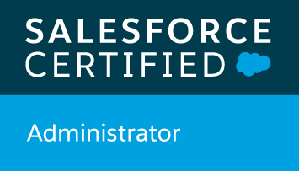

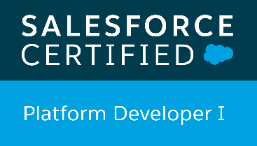

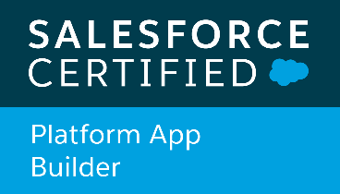

personal info

Email:
sbha092@gmail.com

Website:
www.sarthakbhatnagar.info

Work Eligibility:
OPT with a valid EAD

